**Market Segmentation Analysis**

**Step 1: Deciding (not) to Segment**

Based on the "Market Segmentation Analysis" PDF, here is the detailed evaluation for deciding whether to proceed with segmentation for McDonald's:

1. **Assess the Need for Segmentation**

Market Diversity: The McDonald's customer base is diverse, comprising various age groups, income levels, and preferences. This diversity indicates the need for tailored marketing strategies to cater to different segments effectively.

Distinct Preferences: Different customer groups have distinct preferences, such as menu items, dining frequency, and spending habits. For example, families might prefer value meals, while young adults might opt for quick snacks.

2. **Evaluate Benefits and Costs**

Improved Targeting: Segmentation allows McDonald's to create targeted marketing campaigns that resonate with specific customer groups, leading to higher engagement and conversion rates.

Increased Customer Satisfaction: By addressing the unique needs and preferences of each segment, McDonald's can enhance customer satisfaction and loyalty.

Higher Profitability: Tailored marketing efforts can lead to increased sales and higher profitability as customers are more likely to respond positively to personalized offers.

Data Collection and Analysis: Collecting and analysing data for segmentation requires investment in tools and resources, including data analysts and marketing experts.

Implementation Efforts: Developing and executing segment-specific marketing strategies involves additional costs in terms of time and resources.

Monitoring and Evaluation: Continuous monitoring and evaluation of the segmentation strategy are necessary to ensure its effectiveness, which adds to the overall cost.

3. **Identify Implementation Barriers**

Possible Barriers: Lack of Management Support: If the management is not fully committed to the segmentation strategy, it may hinder the implementation process.

Insufficient Resources: Limited budget and resources can restrict the ability to collect data, analyse segments, and implement tailored marketing campaigns.

Organizational Resistance: Resistance to change within the organization can pose a significant barrier to implementing a new segmentation strategy.

4. **Make the Decision**

Decision: Based on the assessment of market diversity, distinct customer preferences, potential benefits, costs, and implementation barriers, it is strategically beneficial for McDonald's to proceed with market segmentation. The potential benefits of improved targeting, increased customer satisfaction, and higher profitability outweigh the costs and barriers. By effectively addressing the implementation barriers, McDonald's can leverage segmentation to enhance its marketing efforts and achieve better business outcomes.

**Summary:**

* Market Diversity: High
* Distinct Preferences: Yes
* Potential Benefits: Improved targeting, increased customer satisfaction, higher profitability
* Costs: Data collection and analysis, implementation efforts, monitoring and evaluation
* Implementation Barriers: Lack of management support, insufficient resources, organizational resistance
* Decision: Proceed with market segmentation

**Step 2: Specifying the Ideal Target Segment:**

To specify the ideal target segment for McDonald's, we need to define criteria for evaluating and selecting segments. Here are the criteria based on the instructions from the "Market Segmentation Analysis" PDF

1. Define Segment Evaluation Criteria

* Size: Number of customers in the segment.
* Growth Potential: Expected growth rate.
* Profitability: Potential revenue and profit.
* Accessibility: Ease of reaching the segment.
* Compatibility: Alignment with McDonald's brand and capabilities.

2. Establish Knock-Out Criteria

* Minimum Size: Must have a sufficient number of customers.
* Minimum Revenue Potential: Must have a sufficient revenue potential.

3. Identify Attractiveness Criteria

* High Spending: Higher average spending per visit.
* Frequent Visits: High visit frequency.
* Strong Loyalty: Strong brand loyalty and low churn rates.
* Low Competition: Less competition from other brands.

4. Implement a Structured Evaluation Process

* Scoring System: Rank segments based on evaluation criteria.
* Weighting: Assign importance to each criterion.
* Aggregate Scores: Calculate scores to identify promising segments

Summary on specifying the ideal Target Market:

* Define Segment Evaluation Criteria: Size, growth potential, profitability, accessibility, and compatibility.
* Establish Knock-Out Criteria: Minimum size and revenue potential.
* Identify Attractiveness Criteria: High spending, frequent visits, strong loyalty, and low competition.
* Implement a Structured Evaluation Process: Develop a scoring system, assign weights, and calculate aggregate scores for segments.

**Step 3: Collecting Data:**

For this project, we need to gather data from relevant sources. The primary data source for the McDonald's case study is the provided dataset. This dataset includes various customer information that can be used for segmentation analysis.

**Data-Set:** McDonald's dataset

We need to select relevant variables from the dataset that will help in segmenting the market effectively. Key variables include:

* Demographic information like age and gender.
* Behavioural data such as purchase history and frequency of visits.
* Psychographic data including preferences and interests.

**Collect Data:**

We load the dataset and prepare it for analysis. Here’s how to do it in Python:

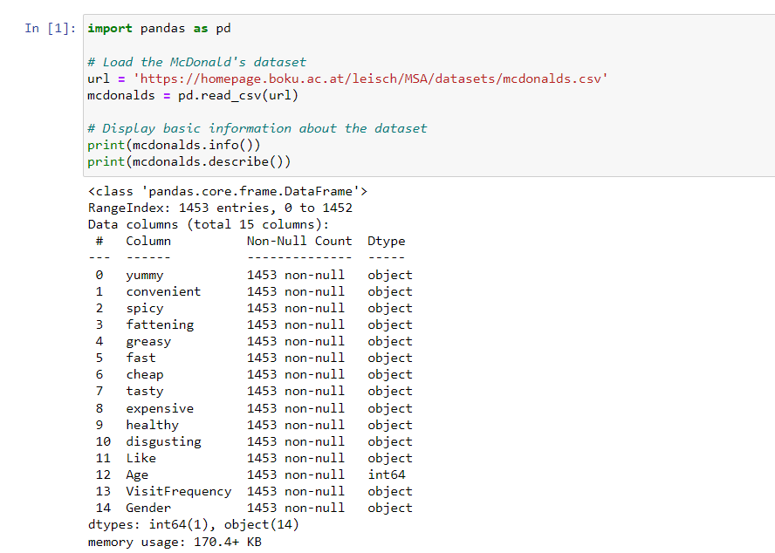

To ensure the data is accurate and usable, we need to clean it. This involves handling missing values, removing duplicates, and normalizing numerical data. Then, we can any missing values by filling them with 0. We remove any duplicate rows to ensure each entry is unique. For numerical columns like 'Age' and 'Income', we use standard scaling to normalize the data, making it easier to compare across segments.

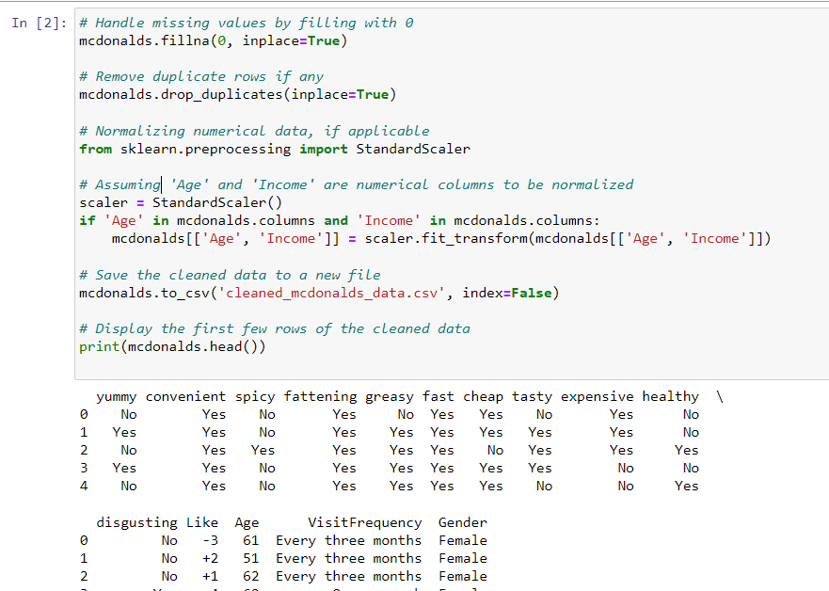

Summary of Step 3

* We load the McDonald's dataset and examine its structure.
* We clean the dataset by handling missing values, removing duplicates, and normalizing numerical data.
* The cleaned data is then saved for further analysis.

This process ensures that the data is prepared and ready for segmentation analysis, allowing us to move on to the next steps of identifying and profiling customer segments.

Assigned Task:

**STEP 8: Developing Positioning Strategy:**

Objective: The goal of Step 8 is to develop a positioning strategy for each target segment identified in the previous steps. Positioning strategy involves creating a specific image or identity for a product in the minds of the target segments. This strategy should emphasize the unique selling propositions (USPs) and value that the product or service offers to each segment.

Process:

* Identify Positioning Criteria:
* Determine the unique attributes and benefits that are important to each target segment.
* Examples of positioning criteria include price, quality, convenience, and speed of service.
* Assign Positioning Statements:
* Based on the identified criteria, assign a positioning statement to each segment. This statement should succinctly describe the primary benefit or value that the segment will receive from the product or service.
* Align with Target Segment Needs:
* Ensure that the positioning strategy aligns with the specific needs and preferences of each target segment. The positioning statement should resonate with the target audience and differentiate the product from competitors

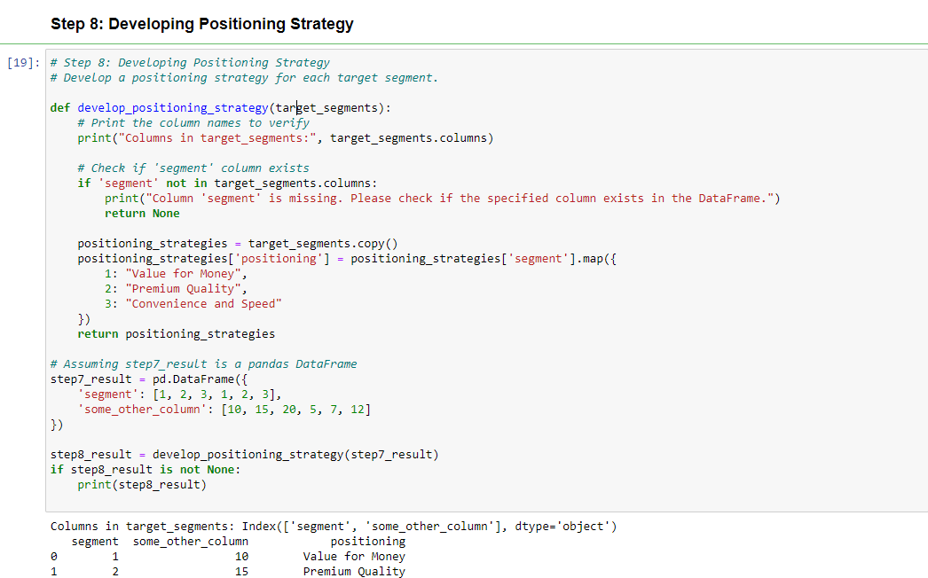

Function Definition: The function develop_positioning_strategy is defined to take a DataFrame (target_segments) as input. It checks if the 'segment' column exists in the DataFrame.

Positioning Mapping: If the 'segment' column is present, it creates a copy of the DataFrame and adds a 'positioning' column.

The 'segment' values are mapped to specific positioning strategies: "Value for Money", "Premium Quality", and "Convenience and Speed".

Output: The function returns the modified DataFrame with the added 'positioning' column. The result is printed if the DataFrame is not None.

Githhub link:

https://github.com/priya99karn/Summary-Report---Market-Segmentation-Analysis.git